SIMATS ENGINEERING
Assignment-1

CO1: Analyze the mobile network components, mobile base station, mobile infrastructures and protocols in cellular systems.
__________________________________________________________________________
Assignment Title: Design, Analyse and Validate an Efficient Cellular Network Strategy for a University Mobile Communication System (Total Marks - 50)
Duration: 1 week
__________________________________________________________________________
Scenario — University Mobile Cellular Communication System
A university campus and its surrounding area rely on a mobile cellular communication system to support students, faculty, administrative staff, and visitors. Mobile users make voice calls, access learning platforms, exchange messages, and use data services while moving between campus buildings and nearby locations.
The cellular system consists of mobile stations, base station subsystems, network switching subsystems, access channels, and a core network connected through a Public Land Mobile Network (PLMN). Network performance is affected by cell size, frequency reuse, co-channel and adjacent-channel interference, mobility, handoff, roaming, and the protocol stacks used to exchange information.
The system may need to support:
1,000 → 10,000 → 50,000+ mobile users
You are required to investigate, design and compare at least three meaningfully different cellular network strategies or configurations for providing reliable communication as the number of users and their movement increase.
Your solution must consider network architecture, access channels, frequency allocation and interference, mobility management, handoff and roaming, performance criteria, and the operation of the cellular system. Any configuration or resource-planning overhead must be included in your analysis.
Design Challenge:
The university now needs to support 50,000 active mobile users during peak hours across the campus and nearby residential area. Users move frequently between cells, while the network infrastructure and frequency resources are limited. Re-evaluate your original design and determine whether it should be retained, modified or redesigned.
__________________________________________________________________________
TASK 1 – Design the Cellular Network Strategy 5 Marks
Design and propose at least three meaningfully different strategies or configurations for supporting mobile cellular communication in the given scenario.
The three approaches must represent distinct strategies. Merely changing labels or describing the same configuration in different words will not be considered as different approaches.
Your proposed approaches must include:
1. Cell and Frequency Planning: Analyze and propose a suitable cell and frequency planning approach to improve coverage, frequency reuse, and interference management.
2. Mobility and Handoff: Evaluate and propose suitable mobility, handoff, or roaming techniques to maintain seamless connectivity.
3. Basic Concept: Illustrate the fundamental principle and working mechanism of each proposed approach and its expected benefits.
4. Architecture Diagram: Design a suitable technical architecture diagram or flowchart illustrating the components and operational flow of each approach.
5. Justification: Evaluate the advantages, limitations, and feasibility of each approach and justify its selection for further investigation.
6. Network Components: Identify the Mobile Station (MS), Base Station Subsystem (BSS), Network Switching Subsystem (NSS), and Core Network components, wherever applicable, and illustrate their roles.
You are expected to design and select the approaches independently. The appropriateness and diversity of the selected strategies form part of the assessment.

Evidence Expected
Three meaningfully different cellular network strategies, supported by diagrams, identification of the design strategy, relevant architecture components, and justification for selecting each approach.
__________________________________________________________________________
TASK 2 – Identify the Basic Network Operation 2 Marks
For each of the proposed strategies, identify the basic network operation or resource that predominantly affects its performance.
Discuss:
- Identify the primary network operation or resource for each proposed strategy.
- Specify where the selected operation or resource occurs within the cellular system.
- Justify the suitability of the selected operation or resource for performance analysis.
- Analyze its behaviour changes as the number of users and mobility events increases.
- Relate the selected operation or resource to the overall behaviour and performance of the cellular network.
Evidence Expected
Correct identification and justification of the dominant operation or resource for each proposed strategy.
__________________________________________________________________________
TASK 3 – Analyze Network Capacity and Resource Requirements 6 Marks
Analyze the resource and capacity requirements for each proposed approach using appropriate calculations and technical reasoning.
Analyze and evaluate the proposed approaches based on the following criteria:
- Estimate the number of users and their expected traffic demand.
- Determine the number of cells or base stations required and their coverage areas, where applicable.
- Evaluate frequency reuse, channel allocation, and interference constraints.
- Calculate access-channel requirements and overall network-resource demand.
- Analyze the impact of handoff and roaming activity on network resource utilization.
- Estimate planning, configuration, and signalling overhead associated with each approach.
- Calculate the total resource requirements by integrating all relevant network components.
- Analyze the assumptions, formulas, reasoning, and calculations supporting the conclusions.
- Justify the comparative performance of the proposed approaches using quantitative analysis rather than merely stating that one approach has higher or lower capacity.

Evidence Expected
A clear, technically justified analysis of capacity and resource requirements for each approach, including relevant calculations and overheads.
__________________________________________________________________________
TASK 4 – Analyse Best, Average and Worst-Case Operating Conditions 4 Marks
Analyse the performance of each strategy under different operating conditions.
Evaluate the following aspects, wherever applicable:
- Determine the conditions under Examine each strategy achieves optimal performance.
- Assess the expected performance of each strategy under normal operating conditions.
- Examine the limitations of each strategy under adverse operating conditions.
- Evaluate the influence of interference, user density, access-channel contention, handoff frequency, and roaming on network performance across different scenarios.

Do not simply provide a table of performance values. Illustrate the conditions that lead to each case.
Evidence Expected
A justified best-, average- and worst-case analysis for the proposed approaches, supported by technical reasoning.
__________________________________________________________________________
TASK 5 – Perform Comparative Performance Analysis 3 Marks
Compare the growth and performance behaviour of the proposed cellular strategies as the number of users increases.
Discuss:
- Appropriate performance criteria, such as throughput, delay, call-drop rate, handoff latency, interference, coverage and resource utilisation
- Analyze each strategy behaves as the user population grows
- Analyze the performance of the proposed approaches differs
- Determine the observed behaviour means when the system grows from 1,000 to 50,000+ users
- Interpret the performance measures in the context of the given application rather than merely listing values.

Evidence Expected
A meaningful comparison of the proposed approaches using appropriate cellular network performance criteria.
__________________________________________________________________________
TASK 6 – Formulate the Mobility and Handoff Procedure 3 Marks
- For the selected mobility management approach, formulate the sequence of operations performed when a mobile station moves from one cell to another.
- Specify the serving cell, target cell, and roles of the mobile station and base station components.
- Determine the handoff trigger, signalling sequence, and protocol operations involved.
- Identify the required network resources, successful completion conditions, and possible handoff failures or service interruptions in accordance with the proposed design.
Evidence Expected
A clearly formulated handoff procedure with its components, trigger, sequence of operations and completion condition.
_______________________________________________________________________
TASK 7 – Examine the protocol stack architecture and its impact on network performance.
4 Marks
For the selected cellular communication strategy, analyze the relevant protocol stack and its role in network communication.
- Illustrate the functions of the relevant protocol layers in the selected system.
- Trace information flow between the mobile station, base station subsystem, and core network.
- Examine the control-plane and user-plane functions, wherever applicable.
- Analyze protocol exchanges support network access, mobility, handoff, and service continuity.
- Assess potential delays, signalling overhead, and interoperability limitations.
- Illustrate the protocol sequence and relate the interactions between layers to the performance of the proposed strategy.
Evidence Expected
A technically accurate protocol-stack representation and explanation of the interaction among relevant components.
__________________________________________________________________________

TASK 8 – Model and Test the Proposed Strategies 4 Marks
Model, simulate or otherwise test the proposed cellular network strategies under comparable conditions.
Use user-load levels of approximately:
1,000 → 10,000 → 25,000 → 50,000 users
Ensure that:
- All approaches are evaluated using the same or equivalent assumptions
- Testing conditions are kept reasonably consistent
- Appropriate test cases include normal mobility and high-mobility conditions
- Frequency reuse, interference, access channels and handoff are represented where relevant
- The model or simulation corresponds to the strategies analysed in the previous tasks
- The purpose of testing is not merely to demonstrate a working model, but to generate evidence for validating the technical analysis.
Evidence Expected
A working model, simulation or reproducible test procedure for the proposed strategies, with clearly stated assumptions.
__________________________________________________________________________

TASK 9 – Record Experimental Performance 3 Marks
Collect and present performance data for each strategy across the different user-load levels.
Record appropriate measures such as:
- Throughput or available capacity
- Handoff delay or interruption
- Call-drop rate or connection failure rate
- Interference level or channel utilisation
- End-to-end delay and resource utilisation
Present the results using appropriate:
- Tables
- Graphs
- Performance plots
Ensure that the presentation allows the different strategies to be easily compared.
Evidence Expected
Systematically collected performance data presented clearly using appropriate tables and/or graphs.
__________________________________________________________________________
TASK 10 – Compare Expected and Observed Behaviour 4 Marks
Compare your theoretical or design-based expectations with the results obtained from modelling, simulation or testing.
Discuss:
- Whether the observed behaviour agrees with your original expectations
- Examine strategy performs better as the number of users and mobility events increase
- Any differences between expected and observed performance
- Possible reasons for those differences, including interference, signalling, access contention and resource limits
- Interpret the results rather than simply reproducing tables or graphs.
Evidence Expected
A reasoned comparison between the expected and experimentally observed performance of the proposed strategies.
__________________________________________________________________________
TASK 11 – Recommend and Defend the Final Design 4 Marks
Based on your technical analysis and performance findings, recommend the most appropriate cellular network strategy for the university.
Examine the following aspects:
- Select the most suitable strategy based on the analysis and testing results.
- Compare capacity, coverage, interference, user-load performance, handoff, roaming, and service continuity across the proposed approaches.
- Determine the infrastructure requirements, configuration and signalling overhead, limitations, and scalability of each approach.
- Substantiate the recommendation with calculations and testing evidence, considering overall performance and practical feasibility rather than capacity or delay alone.
Evidence Expected
A technically justified final design recommendation supported by both analysis and performance evidence.
__________________________________________________________________________
DESIGN CHALLENGE
TASK 12 – Re-evaluate and Adapt the Design 8 Marks
Changed Requirement
The university now needs to support 50,000 active mobile users during peak hours across the campus and nearby residential area. Users move frequently between cells, while the network infrastructure and frequency resources are limited.
Re-evaluate your original design in response to these changed operating conditions.
You may:
RETAIN → MODIFY → or REDESIGN
your original solution.
A. Impact Analysis – 2 Marks
- Identify Determine has changed from the original problem.
- Examine original assumptions are affected by these changes.
- Illustrate why the number of users, traffic demand, and mobility frequency are important.
- Illustrate limited frequency resources and interference affect the network design.
Evidence Expected
A clear analysis of Analyze the changed requirements affect the original cellular network design.
__________________________________________________________________________
B. Evaluation of the Original Design 2 Marks
Evaluate whether your original recommended strategy remains appropriate.
Consider the following aspects:
- Evaluate the performance of the original strategy with 50,000 active users.
- Determine whether the existing cell layout, frequency allocation, and access channels are sufficient.
- Examine whether handoff and roaming work effectively under heavy user traffic.
- Decide whether another strategy can provide better overall network performance.
Evidence Expected
A technically supported evaluation of the suitability of the original design under the new operating conditions.
__________________________________________________________________________
C. Adaptation or Redesign – 2 Marks
Decide whether to retain, modify or redesign the original solution.
If you modify or redesign it:
- Examine the revised cellular network strategy
- Illustrate has changed in the architecture, frequency plan, mobility handling or resource allocation
- Determine the expected effect on capacity, interference, handoff and service continuity
- If you retain the original solution, provide sufficient technical justification for why no redesign is necessary.
Evidence Expected
An appropriate design response to the changed requirement, with clear technical reasoning.
__________________________________________________________________________

D. Evidence-Based Defence 2 Marks
Defend your final design decision using evidence.
Use:
- Capacity and resource calculations
- Performance results, where appropriate
- User density and traffic demand
- Frequency reuse and interference considerations
- Handoff and roaming performance
- Relevant infrastructure and operational trade-offs
- Your final decision must follow logically from your analysis.
Evidence Expected
A well-supported final design decision integrating technical analysis, performance evidence and the changed system constraints.

1. INTRODUCTION

1.1 Introduction
A cellular communication network is a wireless communication system that allows mobile users to communicate through a group of interconnected cells. Each cell is served by a base station that provides wireless connectivity to mobile devices such as smartphones, tablets and laptops.
Cellular networks are widely used for voice communication, internet access, video streaming, messaging and online applications. They allow users to remain connected while moving from one geographical location to another.
A university campus requires a reliable cellular communication network to support students, faculty members, administrative staff and visitors. Users access online learning platforms, attend video lectures, download study materials, make voice calls and exchange messages throughout the campus.
The network must provide good coverage in classrooms, laboratories, libraries, hostels, cafeterias and nearby residential areas.
As the number of users increases from 1,000 to 10,000 and eventually to 50,000 or more, the network must be capable of handling higher traffic demand without affecting communication quality.
Therefore, an efficient cellular network strategy is required to improve coverage, capacity, frequency utilisation, interference management and mobility.

1.2 Problem Statement
The university currently depends on mobile communication services for academic and administrative activities. As the number of students and staff increases, the existing cellular network may experience congestion, reduced data speeds, call drops and communication delays.
The main problem is to design a cellular network that supports a large number of mobile users while maintaining reliable connectivity.
The network must overcome the following challenges:
- Increasing number of mobile users.
- Limited frequency spectrum availability.
- Interference between neighbouring cells.
- Frequent movement of users between buildings.
- Increased handoff and signalling requirements.
- Limited infrastructure and base station resources.
- High data traffic during peak hours.
- Maintaining continuous communication during mobility.
- An efficient network architecture must be designed to overcome these challenges and support future growth.

1.3 Objectives
The main objectives of this assignment are:
- To understand the basic architecture of cellular communication networks.
- To identify the functions of Mobile Stations, Base Station Subsystems and Network Switching Subsystems.
- To design three different cellular network strategies.
- To analyse cell size and frequency reuse techniques.
- To study co-channel and adjacent-channel interference.
- To calculate network capacity and resource requirements.
- To understand mobility management and handoff procedures.
- To analyse the cellular protocol stack.
- To compare network performance under different user loads.
- To recommend an efficient network design for 50,000 active users.

1.4 Scope of the Project
The proposed cellular network is designed for a university campus and its surrounding residential area.
The system supports:
- Voice calls and messaging.
- Online learning platforms.
- Video lectures and conferences.
- Internet browsing.
- File downloads and uploads.
- Communication between students and faculty.
- Continuous connectivity during user movement.
The design considers three different network approaches: macrocell-based, small-cell-based and hybrid cellular networks.

1.5 Basic Cellular Network Architecture
A cellular network consists of several interconnected components that work together to provide wireless communication.
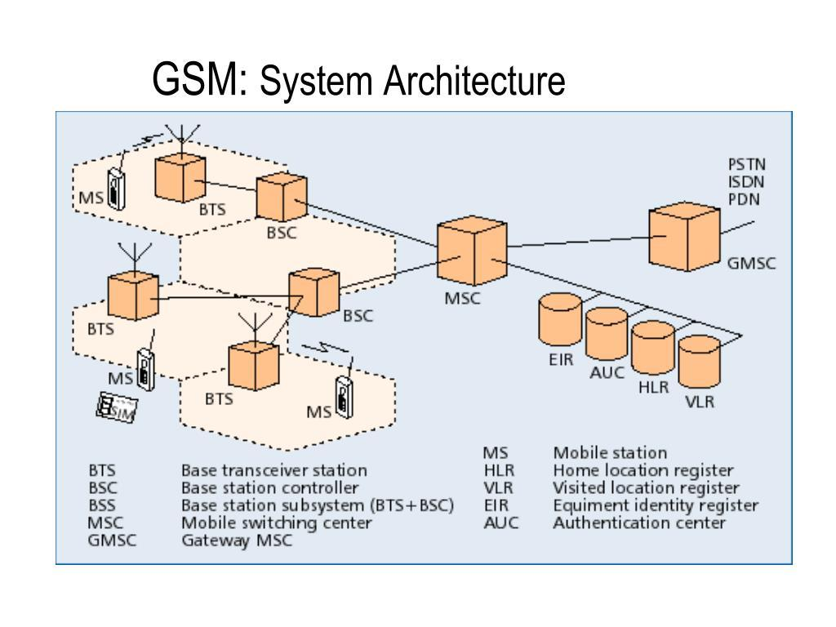

Main components:
1. Mobile Station (MS)
A Mobile Station is the device used by a subscriber to communicate with the cellular network.
Examples include smartphones, tablets and cellular-enabled laptops.
Functions:
- Sends and receives voice and data.
- Communicates with the nearest base station.
- Performs signal measurements.
- Supports mobility between cells.

2. Base Station Subsystem (BSS)
The Base Station Subsystem provides the radio connection between mobile devices and the network.
It consists of:
- Base Transceiver Station (BTS): Transmits and receives radio signals.
- Base Station Controller (BSC): Controls multiple BTS units and manages radio resources and handoffs in GSM networks.
3. Network Switching Subsystem (NSS)
The NSS manages switching, subscriber information and mobility functions in traditional GSM architecture.
Important components include:
- Mobile Switching Centre (MSC).
- Home Location Register (HLR).
- Visitor Location Register (VLR).
- Authentication Centre (AuC).
- Equipment Identity Register (EIR).
4. Core Network
The core network connects the radio access network to external networks and manages subscriber sessions, authentication, mobility and data services.
In modern LTE and 5G networks, the core-network architecture performs functions that are different from the traditional GSM NSS.
5. Public Land Mobile Network (PLMN)
A PLMN is a mobile communication network operated by a telecommunications service provider. It provides services to subscribers through interconnected base stations and core-network equipment.

2. TASK 1 – DESIGN THE CELLULAR NETWORK STRATEGY
The university requires three different cellular network strategies to support increasing mobile users.
The three proposed strategies are:
- Traditional Macrocell-Based Network.
- Dense Small-Cell-Based Network.
- Hybrid Macrocell and Small-Cell Network.
- Each strategy has a different architecture, frequency-planning method, mobility mechanism and resource requirement.

2.1 Strategy 1 – Traditional Macrocell-Based Cellular Network

Basic Concept
A macrocell network uses high-power base stations to provide wireless coverage over large geographical areas.
Each macrocell covers a large region and serves multiple mobile users. The base stations are installed at elevated locations such as towers or rooftops.
This strategy is suitable for providing wide-area coverage across the university campus and surrounding residential areas.

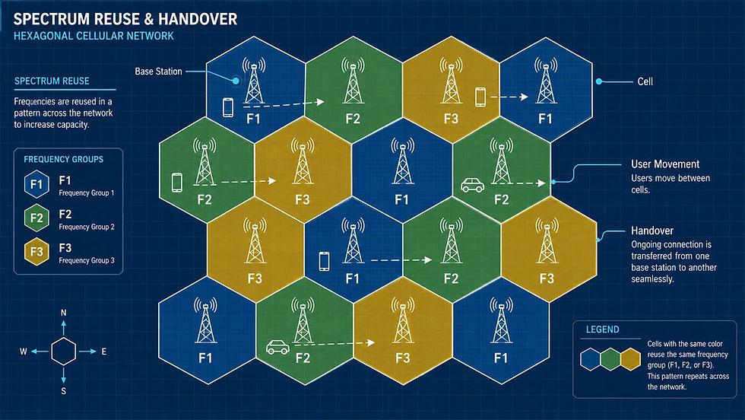

Working Principle
- Mobile users connect to the nearest macrocell base station.
- The base station establishes a wireless connection with the mobile device.
- The BSS manages radio communication.
- The NSS handles switching and mobility management in a GSM-based architecture.
- The core network connects users to internet and communication services.
- When a user moves to another cell, the network performs handoff.

Cell and Frequency Planning
A macrocell covers a relatively large geographical area.
The proposed design uses a reuse-3 frequency allocation approach for illustration.
The available frequency spectrum is divided into three groups:
- Frequency Group A.
- Frequency Group B.
- Frequency Group C.
Neighbouring cells are assigned different groups to reduce co-channel interference.
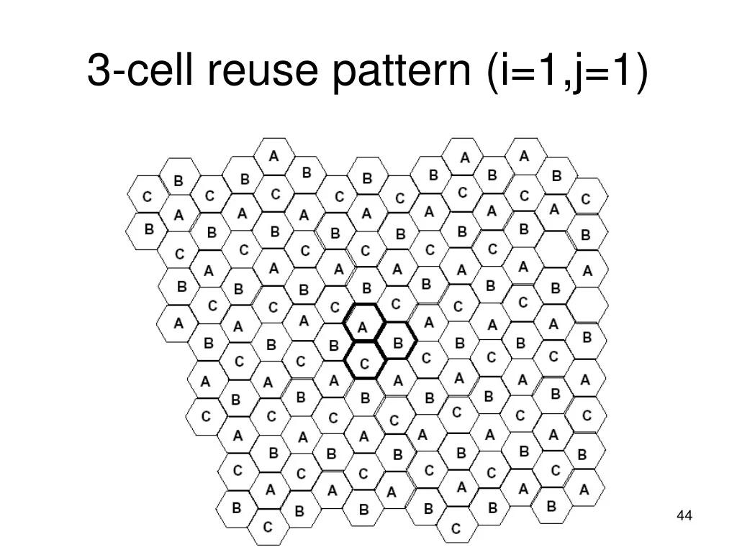

Frequency reuse improves spectrum utilisation because the same frequency group can be reused in sufficiently separated cells.

Mobility and Handoff
When a mobile user moves from one macrocell to another, the network performs handoff.
The mobile station continuously measures the signal strength of the serving cell and neighbouring cells.
When the neighbouring cell provides a better signal, the network initiates the handoff procedure.
Since macrocells cover larger areas, users generally experience fewer cell-boundary crossings than in dense small-cell networks.

Advantages
- Provides wide geographical coverage.
- Requires fewer base stations.
- Easier to manage and maintain.
- Suitable for outdoor communication.
- Lower handoff frequency.
- Provides basic connectivity across the campus.

Limitations
- Limited capacity during peak traffic.
- Indoor coverage may be weak.
- Large cells may experience interference.
- High user density reduces available bandwidth per user.
- Adding capacity may require additional sectors or infrastructure.

Suitability
Macrocell architecture is suitable for basic university coverage. However, it may not provide sufficient capacity when the number of active users reaches 50,000.

2.2 Strategy 2 – Dense Small-Cell-Based Cellular Network

Basic Concept
A small-cell network uses several low-power base stations to provide wireless connectivity over smaller geographical areas.
Small cells are installed close to users in locations such as:
- Classrooms.
- Libraries.
- Laboratories.
- Hostels.
- Cafeterias.
- Auditoriums.
- Sports facilities.
Each small cell covers a smaller area compared with a macrocell.

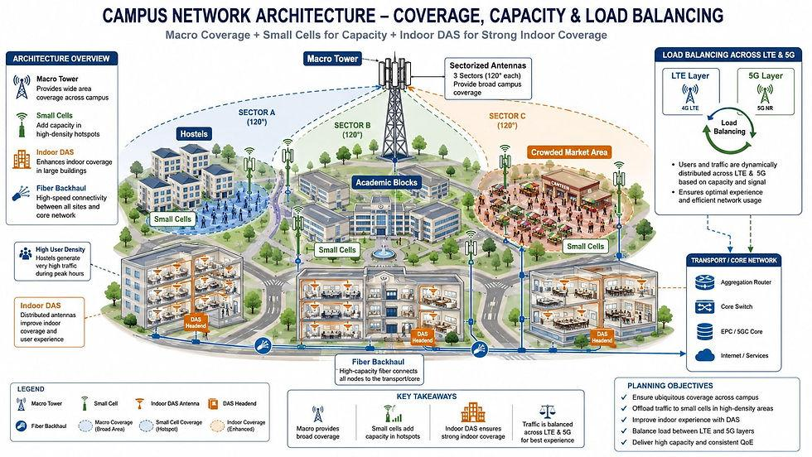

Working Principle
- Small-cell base stations are installed throughout high-density locations.
- Mobile users connect to the nearest small cell.
- Each cell handles a smaller group of users.
- The network reuses available frequencies across separated cells.
- The RAN coordinates radio resources and mobility.
- The core network manages sessions and external connectivity.

Cell and Frequency Planning
The small-cell strategy uses spatial frequency reuse.
The same frequency resources can be reused in different small cells when interference is properly controlled.
For example, a library and an auditorium can use the same frequency resources if their radio coverage and interference conditions permit it.
Important techniques include:
- Frequency reuse.
- Power control.
- Interference coordination.
- Dynamic resource allocation.
- Proper base station placement.

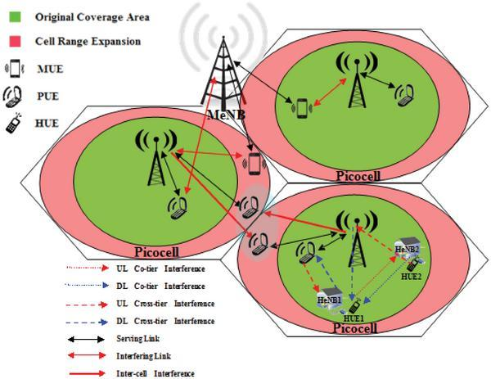

Mobility and Handoff
Small cells have shorter coverage ranges. Therefore, users may move between cells more frequently.
For example, a student walking from a classroom to the library may move between several small-cell coverage areas.
The network must perform frequent handoffs to maintain continuous connectivity.
Handoff optimisation techniques include:
- Signal measurement.
- Neighbour-cell identification.
- Handoff hysteresis.
- Time-to-trigger.
- Target-cell resource reservation.
- Connection confirmation.

Advantages
- Provides high local capacity.
- Improves indoor coverage.
- Supports large numbers of users.
- Allows better frequency reuse.
- Reduces the transmission distance.
- Suitable for crowded locations.

Limitations
- Requires many base stations.
- Installation and maintenance costs are higher.
- Frequent handoffs increase signalling.
- Interference coordination is necessary.
- Reliable backhaul connectivity is required.

Suitability
Small-cell networks are suitable for high-density university locations. However, using small cells throughout the entire campus may increase infrastructure and maintenance requirements.

2.3 Strategy 3 – Hybrid Macrocell and Small-Cell Network

Basic Concept
A hybrid cellular network combines macrocell and small-cell technologies.
The macrocell layer provides wide-area coverage, while small cells provide additional capacity in crowded locations.
This approach combines the advantages of both previous strategies.

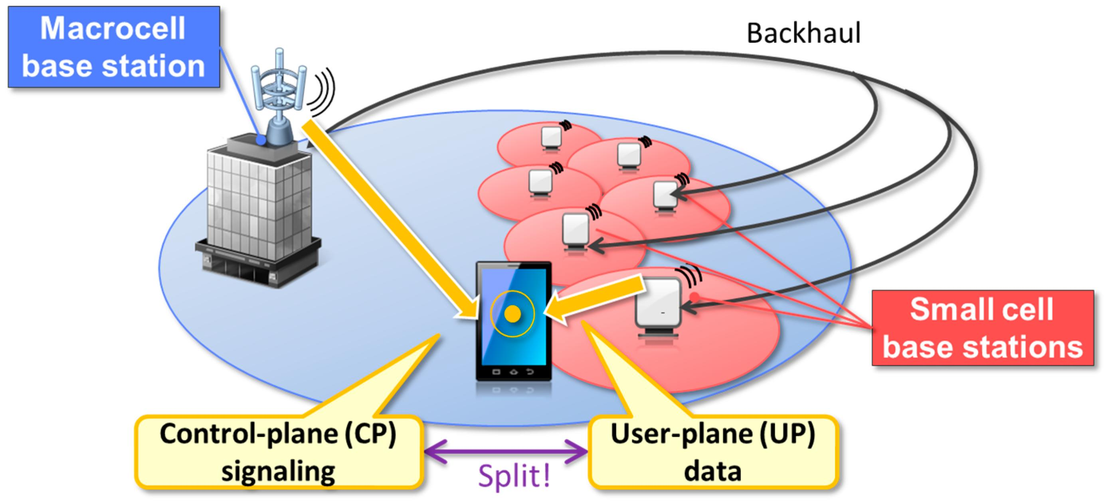

Working Principle
- Macro base stations provide continuous coverage.
- Small cells are installed in crowded buildings.
- Mobile users connect to the most suitable cell.
- The macro layer provides coverage when users move outside small-cell areas.
- Small cells handle high data traffic in crowded locations.
- The RAN coordinates mobility and resource allocation.
- The core network provides authentication, session management and internet connectivity.

Cell and Frequency Planning
The hybrid approach uses different frequency-planning techniques for the two layers.
Macrocell layer:
- Reuse-3 planning.
- Large coverage.
- Sector-based resource allocation.
Small-cell layer:
- Reuse-1 where interference conditions permit.
- Low transmission power.
- Dense spatial reuse.
- Dynamic resource coordination.

Mobility and Handoff
The macro layer acts as a coverage foundation.
When a user enters a crowded building, the network can transfer the connection to a small cell if it provides better radio quality and sufficient capacity.
When the user leaves that building, the connection can return to the macro layer.
This provides better service continuity.

Advantages
- Combines wide coverage and high capacity.
- Supports large numbers of users.
- Improves indoor and outdoor connectivity.
- Reduces the need for small cells in every location.
- Supports flexible network expansion.
- Provides better mobility support.
- Allows traffic to be distributed between network layers.

Limitations
- Requires coordinated network management.
- Installation planning is more complex.
- Inter-layer handoff must be optimised.
- Requires reliable small-cell backhaul.
- Initial configuration requires careful planning.

Suitability
The hybrid strategy is the most suitable starting design for the university because it combines wide-area coverage with additional capacity in crowded locations.

2.4 Comparison of the Three Strategies
Criteria | Macrocell | Small-cell | Hybrid
Coverage | Wide | Local | Wide and local
Capacity | Moderate | High | High
Number of base stations | Low | High | Moderate
Frequency reuse | Planned reuse | Spatial reuse | Combined reuse
Handoff frequency | Low | High | Moderate
Indoor coverage | Limited | Good | Good
Infrastructure cost | Lower initial site count | Higher | Balanced
Scalability | Limited | High | High
Suitability for 50,000 users | Low | High | High
Selection: All three approaches will be analysed in the following tasks. The hybrid network is selected as the preferred design for further investigation.

3. TASK 2 – IDENTIFY THE BASIC NETWORK OPERATION
Each cellular network strategy depends on different network operations and resources. The performance of the network is affected by the availability of radio resources, frequency allocation, interference and mobility management.

3.1 Strategy 1 – Macrocell Network
Primary operation: Radio Resource Allocation and Frequency Reuse
Radio resource allocation determines how available frequencies and communication channels are shared among mobile users.
Location of operation:
- Base Transceiver Station.
- Base Station Controller.
- Radio Access Network.
Importance:
A macrocell serves a large number of users. All connected users share the available radio resources.
When the number of users increases, the available bandwidth must be divided among more users. This reduces the average data rate.
Behaviour with increasing users:
- At 1,000 users, sufficient radio resources are available.
- At 10,000 users, resource utilisation increases.
- At 25,000 users, congestion may occur.
- At 50,000 users, the network may experience significant capacity limitations.

3.2 Strategy 2 – Small-Cell Network
Primary operation: Inter-Cell Interference Coordination
Inter-cell interference occurs when neighbouring base stations transmit using overlapping radio resources and affect each other's signals.
Location of operation:
- Small-cell base stations.
- Radio Access Network.
- Network coordination controller.
Importance:
Small cells improve capacity through spatial frequency reuse. However, the close placement of multiple base stations can increase interference.
The network must coordinate transmission power, frequency resources and scheduling.
Behaviour with increasing users:
- More users share each small cell's resources.
- Additional small cells can increase capacity.
- Interference coordination becomes more important.
- Frequent movement increases handoff signalling.

3.3 Strategy 3 – Hybrid Network
Primary operation: Load Balancing and Mobility Coordination
Load balancing distributes mobile users between macrocell and small-cell layers.
Location of operation:
- Macro base stations.
- Small-cell base stations.
- RAN controller.
- Core network mobility functions.
Importance:
If a large number of users connect to one macrocell, the network can direct suitable users towards nearby small cells.
This reduces congestion and improves resource utilisation.
Behaviour with increasing users:
- Macro cells provide continuous coverage.
- Small cells handle crowded locations.
- Network coordination distributes traffic.
- Mobility management maintains connectivity between layers.

3.4 Overall Comparison
Strategy | Dominant operation | Main performance factor
Macrocell | Radio resource allocation | Available bandwidth
Small-cell | Inter-cell interference coordination | Spatial reuse
Hybrid | Load balancing and mobility coordination | Resource distribution

4. TASK 3 – ANALYSE NETWORK CAPACITY AND RESOURCE REQUIREMENTS
Network capacity refers to the maximum amount of communication traffic that a cellular network can support within a given period.
Capacity planning is important because the university must support increasing numbers of mobile users without affecting communication quality.
The following calculations use illustrative engineering assumptions because the assignment does not provide actual campus measurements, licensed spectrum or operator traffic records.

4.1 Estimation of Number of Users
The proposed network is evaluated using four user-load levels.
Stage | Number of active users
Stage 1 | 1,000
Stage 2 | 10,000
Stage 3 | 25,000
Stage 4 | 50,000
The network must support students, faculty, administrative staff and visitors.

4.2 Estimation of Traffic Demand
Assumptions:
- Active users = U
- Data concurrency = 15%
- Average data rate per concurrent user = 0.5 Mbps
- Voice concurrency = 5%
- Voice bandwidth per call = 24 kbps = 0.024 Mbps
Formula 1: Concurrent Data Users
\[ D=U\times 0.15 \]
Formula 2: Data Traffic Demand
\[ T_d=D\times 0.5 \]
Formula 3: Voice Traffic Demand
\[ T_v=U\times 0.05\times0.024 \]
Formula 4: Total Traffic Demand
\[ T=T_d+T_v \]

Calculation for 1,000 users
Concurrent data users:
\[ 1000\times0.15=150 \]
Data demand:
\[ 150\times0.5=75\ Mbps \]
Voice calls:
\[ 1000\times0.05=50 \]
Voice demand:
\[ 50\times0.024=1.2\ Mbps \]
Total demand:
\[ 75+1.2=\boxed{76.2\ Mbps} \]

Calculation for 10,000 users
D =10000 * 0.15 = 1500
T_d = 1500 * 0.5 = 750 Mbps
T_v = 10000 * 0.05 * 0.024 = 12 Mbps
T=750+12 = 762 Mbps

Calculation for 25,000 users
D = 25000 * 0.15 = 3750
T_d = 3750 * 0.5=1875 Mbps
T_v = 25000 * 0.05 * 0.024=30 Mbps
T=1875+30 = 1905 Mbps

Calculation for 50,000 users
D = 50000 * 0.15 = 7500
T_d = 7500 * 0.5 = 3750 Mbps
T_v = 50000 * 0.05 * 0.024 = 60 Mbps
T = 3750+60 = 3810 Mbps

Traffic Demand Summary
Users | Data demand | Voice demand | Total demand
1,000 | 75 Mbps | 1.2 Mbps | 76.2 Mbps
10,000 | 750 Mbps | 12 Mbps | 762 Mbps
25,000 | 1,875 Mbps | 30 Mbps | 1,905 Mbps
50,000 | 3,750 Mbps | 60 Mbps | 3,810 Mbps
Cinq raisons pour lesquelles l'infrastructure numérique est l'un des thèmes d'investissement les plus prometteurs
schroders.com
Interpretation: As the number of users increases, the traffic demand also increases. Therefore, additional network capacity and efficient resource management are required.

4.3 Determination of Number of Cells and Base Stations
The number of cells required depends on the geographical coverage area and cell radius.
The approximate area of a regular hexagonal cell is:
A = 3/sqrt{3}}{2}r^2
Where:
- A = Area of the cell.
- r = Cell radius.
Assume the university and surrounding residential area cover 10 km².

Macrocell Calculation
Assumed macrocell radius:
\[ r=0.8\ km \]
\[ A=2.598\times(0.8)^2 \]
\[ A=1.663\ km^2 \]
Number of ideal cells:
N = 10/1.663 = 6.01
Considering overlap, sectorisation and practical coverage, the illustrative design uses 12 macro sites with three sectors each.
Total sectors:
12 * 3= 36 sectors

Small-Cell Calculation
Assumed small-cell radius:
r = 0.15 km
A = 2.598 * (0.15)^2
A = 0.0585 km^2
Ideal cells for blanket geometric coverage:
N = 10/0.0585 approx171
However, the proposed design uses 100 small cells as capacity nodes in selected high-density locations. They are not intended to provide uniform coverage of the entire 10 km² area.

Proposed Deployment
Strategy | Proposed deployment
Macrocell | 12 macro sites and 36 sectors
Small-cell | 100 small cells
Hybrid | 12 macro sites and 60 small cells

4.4 Frequency Reuse and Channel Allocation
Frequency reuse allows the same frequency resources to be used in different cells separated by sufficient distance.
This improves the utilisation of limited radio spectrum.
web.stanford.edu
Macrocell strategy
The macrocell network uses a reuse-3 planning assumption.
Available spectrum:
B = 40 MHz
Bandwidth per frequency group:
B_g = 40/3
B_g = 13.33 MHz
Small-cell strategy
The small-cell network uses reuse-1 where interference conditions permit.
Each small cell can reuse the 40 MHz planning bandwidth with proper interference management.
Hybrid strategy
The hybrid network combines:
- Reuse-3 planning for the macro layer.
- Reuse-1 planning for suitable small-cell locations.
Interference coordination between the layers.

4.5 Interference Management
Interference reduces the quality of received signals and can decrease the data rate available to users.
There are two important types.
1. Co-channel Interference
Co-channel interference occurs when two or more cells use the same frequency resources and their transmissions interfere with one another.
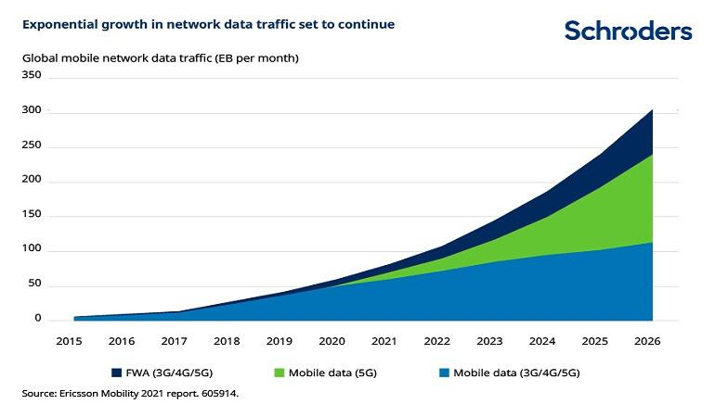
Methods to reduce co-channel interference:
- Increase reuse distance where necessary.
- Apply transmit-power control.
- Use sector antennas.
- Coordinate neighbouring cells.
- Optimise base station placement.
2. Adjacent-Channel Interference
Adjacent-channel interference occurs when signals transmitted using nearby frequency channels affect one another.
Methods to reduce adjacent-channel interference:
- Proper frequency separation.
- Accurate transmitter filtering.
- Guard-band planning where required.
- Proper frequency assignment.
- Radio equipment calibration.

4.6 Radio Capacity Calculation
The simplified radio capacity formula is:
C=B * eta * F
Where:
- C = Capacity.
- B = Available bandwidth in MHz.
- η = Spectral efficiency in bit/s/Hz.
- F = Usable payload factor.
Assumptions:
eta=2 bit/s /Hz
F = 0.75

Macrocell Capacity
Bandwidth per sector:
40/3 = 13.33 MHz
Capacity per sector:
C=13.33 * 2 * 0.75
C=20 Mbps
For 36 sectors:
C=36 * 20
C = 720 Mbps = 0.72 Gbps

Small-Cell Capacity
Bandwidth per small cell:
B=40 MHz
Capacity per cell:
C=40 * 2 * 0.75
C=60 Mbps
For 100 small cells:
C=100 * 60
C = 6000 Mbps = 6 Gbps

Hybrid Network Capacity
Macro capacity:
C_m = 0.72 Gbps
Small-cell capacity:
C_s = 60 * 60 = 3600 Mbps
C_s = 3.6 Gbps
Total capacity:
C_h=0.72+3.6
C_h=4.32 Gbps
These are simplified nominal capacity estimates. Actual simultaneous capacity depends on spectrum coordination, interference, scheduling, backhaul and other implementation factors.

4.7 Comparison of Network Capacity
Strategy | Estimated capacity
Macrocell | 0.72 Gbps
Small-cell | 6.00 Gbps
Hybrid | 4.32 Gbps
Interpretation:
- Macrocell networks provide lower estimated capacity.
- Small-cell networks provide higher spatial reuse and capacity.
- Hybrid networks balance capacity and coverage.

4.8 Access-Channel Requirements
Access channels allow mobile devices to request initial communication with the cellular network.
They are used during:
- Network registration.
- Connection establishment.
- Random access.
- Paging response.
- Handoff-related access.
For an illustrative calculation, assume 5% of active users initiate an access procedure in one busy minute.
A=U * 0.05
Users | Access attempts per minute | Average attempts per second
1,000 | 50 | 0.83
10,000 | 500 | 8.33
25,000 | 1,250 | 20.83
50,000 | 2,500 | 41.67
At 50,000 users, the network must handle approximately 41.67 access attempts per second on average under this assumption.
Actual access-channel planning must also account for sudden bursts and collisions.

4.9 Handoff Resource Requirements
Handoff requires additional signalling and radio resources.
Assume that 2% of active users perform handoff in one minute under normal mobility.
H=U * 0.02
Users | Normal handoffs/minute
1,000 | 20
10,000 | 200
25,000 | 500
50,000 | 1,000
Under high mobility, assume a 5% handoff rate per minute.
At 50,000 users:
H=50000 * 0.05
H=2500 handoffs/minute
This shows that mobility management becomes increasingly important as the user population grows.

4.10 Planning and Configuration Overhead
Resource | Macrocell | Small-cell | Hybrid
Site planning | Moderate | High | High initially
Frequency planning | Moderate | High | High
Handoff management | Lower | Higher | Moderate
Backhaul | Fewer links | Many links | Moderate
Maintenance | Lower | Higher | Moderate
Interference control | Important | Very important | Very important

4.11 Overall Resource Analysis
The capacity analysis shows that the macrocell design cannot support the estimated 50,000-user demand by itself.
The small-cell design provides higher nominal capacity but requires many base stations and reliable backhaul.
The hybrid design provides 4.32 Gbps of estimated capacity against 3.81 Gbps of estimated demand.
Therefore, the hybrid strategy is suitable for further development, but it requires additional monitoring and capacity planning to handle peak-hour traffic.

5. TASK 4 – ANALYSE BEST, AVERAGE AND WORST-CASE OPERATING CONDITIONS
Network performance changes depending on the number of users, their movement, interference levels and available radio resources.
Each strategy must be analysed under three operating conditions.

5.1 Strategy 1 – Macrocell Network
Best-case condition
- Users are distributed evenly.
- The network has sufficient available bandwidth.
- There is low interference.
- Most users are outdoors.
- Movement between cells is limited.
Expected performance:
The macrocell network provides stable coverage and fewer handoffs. Users receive reliable communication because the number of active connections is within the available capacity.

Average-case condition
- Moderate number of users.
- Some users are inside buildings.
- Normal movement between classrooms and hostels.
- Moderate interference.
Expected performance:
The network continues to provide communication, but some cells may experience congestion. Indoor signal strength may decrease because of walls and building structures.
Worst-case condition
- 50,000 active users.
- Large groups concentrated near a few macro sites.
- High traffic during events.
- Increased interference.
- Frequent communication requests.
Expected performance:
The available capacity becomes insufficient. Users may experience slow internet speeds, increased delays and connection failures.

5.2 Strategy 2 – Small-Cell Network
Best-case condition
- Small cells are placed close to users.
- Traffic is distributed properly.
- Backhaul connectivity is reliable.
- Interference is controlled.
- User movement is moderate.
Expected performance:
The network provides high local capacity and good indoor coverage. Shorter transmission distances improve signal quality.
Average-case condition
- Moderate user movement.
- Several neighbouring cells are active.
- Traffic varies between buildings.
- Some handoff procedures occur.
Expected performance:
The network provides good throughput, but handoff and interference coordination require additional resources.
Worst-case condition
- Very high mobility.
- Many users moving between small cells.
- High interference.
- Backhaul congestion.
- Sudden traffic bursts.
Expected performance:
Frequent handoffs may increase signalling overhead. Some users may experience temporary interruptions or connection failures.

5.3 Strategy 3 – Hybrid Network
Best-case condition
- Macro cells provide complete coverage.
- Small cells are installed in high-demand locations.
- Users are distributed according to traffic requirements.
- Interference is controlled.
- Backhaul is reliable.
Expected performance:
The network provides both wide coverage and high local capacity. Small cells reduce congestion in crowded areas.
Average-case condition
- Normal university activity.
- Students move between buildings.
- Traffic varies according to class timings.
- Moderate handoff activity.
Expected performance:
The network distributes users between macro and small-cell layers. It provides reliable connectivity with manageable signalling overhead.
Worst-case condition
- 50,000 active users.
- Multiple crowded locations.
- High mobility.
- Limited spectrum.
- Increased handoff and access-channel requests.
Expected performance:
The hybrid network performs better than macro-only architecture, but some small cells may become overloaded. Additional small cells or resource optimisation may be necessary.

5.4 Comparison of Operating Conditions
Strategy | Best case | Average case | Worst case
Macrocell | Stable coverage | Moderate congestion | Capacity limitation
Small-cell | High local throughput | More handoff activity | Interference and signalling overload
Hybrid | High capacity and coverage | Balanced performance | Hotspot congestion possible

5.5 Factors Affecting Performance
1. Interference: Interference reduces signal quality and affects data transmission.
2. User Density: When many users connect to one cell, available radio resources must be shared.
3. Access-Channel Contention: Simultaneous access requests may collide or be delayed.
4. Handoff Frequency: Frequent movement increases signalling and resource requirements.
5. Roaming: When subscribers use a visited operator's network, authentication and subscriber information exchange are required.
6. Backhaul Availability:The connection between base stations and the core network must have sufficient capacity.

6. TASK 5 – PERFORM COMPARATIVE PERFORMANCE ANALYSIS
Comparative performance analysis evaluates how the three proposed cellular network strategies behave when the number of mobile users increases.
The main objective is to identify which network provides better throughput, lower delay, fewer call drops and reliable connectivity.

6.1 Performance Criteria
The following parameters are considered.
1. Throughput: Throughput is the amount of data successfully transmitted through the network in a given period.
Higher throughput provides better internet access, video streaming and online learning experiences.
2. End-to-End Delay: End-to-end delay is the time taken by data packets to travel from the sender to the receiver.
Lower delay is important for video calls, voice communication and interactive applications.
3. Call-Drop Rate: Call-drop rate represents the percentage of ongoing calls that terminate unexpectedly.
A lower call-drop rate indicates better network reliability.
4. Handoff Latency:Handoff latency is the time required to transfer an active connection from one cell to another.
Lower handoff latency improves communication continuity.
5. Interference: Interference occurs when unwanted radio signals affect the communication between mobile devices and base stations.
6. Coverage: Coverage represents the geographical area in which users can obtain reliable cellular services.
7. Resource Utilisation: Resource utilisation indicates how much of the available network capacity is being used.

6.2 Performance at Different User Loads
The following table presents the estimated traffic demand.
Users | Total traffic demand
1,000 | 76.2 Mbps
10,000 | 762 Mbps
25,000 | 1,905 Mbps
50,000 | 3,810 Mbps

Macrocell Performance
At 1,000 users, the macrocell network can provide sufficient capacity.
As the population increases, the number of users sharing each sector increases.
At 10,000 users, the estimated demand of 762 Mbps slightly exceeds the nominal capacity of 720 Mbps.
At 25,000 and 50,000 users, the network experiences severe capacity limitations under the assumed configuration.

Small-Cell Performance
Small-cell networks provide higher capacity through spatial frequency reuse.
At 50,000 users, the estimated demand is 3.81 Gbps, while the nominal capacity is 6 Gbps.
Therefore, the network has sufficient aggregate radio capacity in this simplified model.
However, the number of small cells, interference and backhaul requirements must be considered.

Hybrid Network Performance
The hybrid network combines macrocell coverage with small-cell capacity.
At 50,000 users, the estimated capacity is 4.32 Gbps.
The estimated demand is 3.81 Gbps.
Therefore, the network can support the assumed aggregate demand, but its capacity reserve is relatively limited.

6.3 Comparative Performance Table
Parameter | Macrocell | Small-cell | Hybrid
Throughput | Moderate | High | High
Delay | Increases under congestion | Low near well-served cells | Generally balanced
Call drops | May increase at peak load | Depends on handoff and backhaul | Lower with proper fallback
Handoff latency | Relatively low frequency of handoff | More frequent handoffs | Moderate
Interference | Co-channel interference | Dense-cell interference | Requires inter-layer coordination
Coverage | Wide | Local | Wide and local
Resource utilisation | Limited capacity | High spatial reuse | Balanced allocation

6.4 Interpretation of Results
The comparison shows that the three strategies behave differently as the user population grows.
The macrocell strategy is suitable for smaller populations because it requires fewer base stations and provides wide coverage.
The small-cell strategy is suitable for high-density locations because it provides higher spatial reuse and additional capacity.
The hybrid strategy combines both approaches and offers a practical solution for a university environment.

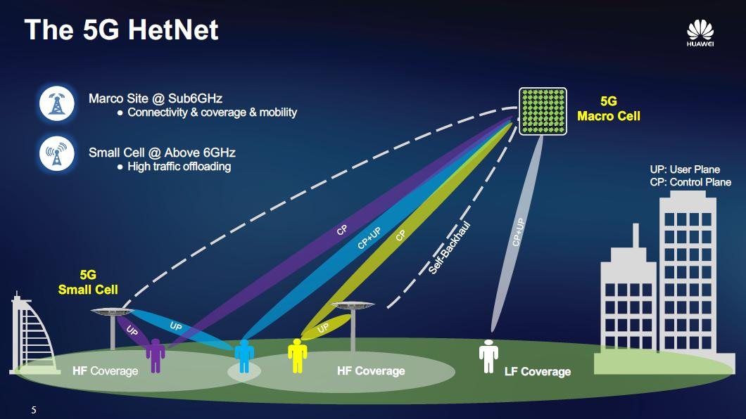

6.5 Overall Finding
The network should not depend only on the number of base stations. It must also consider user distribution, traffic demand, interference, handoff requirements and backhaul capacity.
The hybrid strategy is selected because it provides a balance between network coverage, capacity and mobility support.

7. TASK 6 – FORMULATE THE MOBILITY AND HANDOFF PROCEDURE

7.1 Introduction to Mobility Management
Mobility management is the process of maintaining communication when a mobile user moves from one geographical location to another.
In a cellular network, the coverage area is divided into multiple cells. Each cell is served by a base station.
When a mobile user moves away from the serving cell, the network must transfer the connection to another suitable cell.
This process is called handoff or handover.
For example, a student may be attending an online lecture in a classroom and then walk towards the library. During this movement, the mobile device may change its serving cell.
The network must maintain the connection without interrupting the online lecture.

7.2 Types of Handoff
1. Hard Handoff
In hard handoff, the connection with the current base station is released before a new connection is established.
It follows the principle of break-before-make.
2. Soft Handoff
In soft handoff, the mobile station can maintain connections with multiple base stations during the transition, where the radio technology supports it.
It follows the principle of make-before-break.
3. Intra-Cell Handoff
This occurs when a mobile device changes its radio channel or resource within the same cell.
4. Inter-Cell Handoff
This occurs when a mobile device moves from one cell to another.
5. Inter-System Handoff
This occurs when communication is transferred between different radio access systems or network technologies.

7.3 Components Involved in Handoff
Component | Function
Mobile Station | Measures signal quality and reports measurements
Serving Base Station | Manages the existing connection
Target Base Station | Accepts the incoming connection
BSC / RAN Controller | Coordinates radio resources and handoff where applicable
Core Network | Maintains session and user-plane connectivity

7.4 Handoff Trigger
The handoff process is initiated when the serving cell becomes unsuitable or another cell provides a better connection.
The network considers:
- Received signal strength.
- Signal quality.
- Interference.
- Cell congestion.
- User movement.
Available resources in the target cell.
For LTE and 5G, measurements may include RSRP, RSRQ and SINR.
A simplified handoff condition is:
Q_target >Q_serving + H
Where:
Q_target = Target-cell signal quality.
Q_serving = Serving-cell signal quality.
H = Hysteresis margin.
The network also uses a time-to-trigger condition to prevent unnecessary handoffs caused by short signal fluctuations.

7.5 Step-by-Step Handoff Procedure
Step 1 – Signal Measurement
The mobile station continuously measures the signal strength and quality of the serving cell and neighbouring cells.
Step 2 – Measurement Report
When a configured measurement condition is satisfied, the mobile station sends a measurement report to the serving base station.
Step 3 – Handoff Decision
The serving base station or RAN controller evaluates the measurement report and decides whether a handoff is required.
Step 4 – Target Cell Selection
The network selects a suitable target cell based on signal quality, available resources and network load.
Step 5 – Handoff Request
The serving base station sends a handoff request to the target base station.
Step 6 – Resource Allocation
The target base station checks whether sufficient radio and network resources are available.
Step 7 – Handoff Acknowledgement
If the target cell accepts the request, it sends an acknowledgement to the serving network.
Step 8 – Handoff Command
The mobile station receives the handoff command and prepares to connect to the target cell.
Step 9 – Target Cell Connection
The mobile station synchronises with the target cell and completes the required access procedure.
Step 10 – Handoff Completion
The network updates the user-plane path and releases the previous cell's radio resources.

7.6 Successful Handoff Conditions
A handoff is considered successful when:
- The target cell accepts the mobile device.
- Required radio resources are allocated.
- The mobile station successfully connects to the target cell.
- The network updates the communication path.
- The ongoing service continues without unexpected disconnection.
- The previous cell releases the old resources.

7.7 Possible Handoff Failures
Failure | Explanation | Solution
Weak target signal | Target cell cannot provide a reliable connection | Select a better neighbour
Resource unavailability | Target cell is congested | Use admission control
Signalling failure | Handoff messages are delayed or lost | Improve signalling reliability
Ping-pong handoff | User repeatedly changes between cells | Tune hysteresis and time-to-trigger
Backhaul failure | Target cell cannot communicate with the core | Provide reliable backhaul
Radio link failure | Signal becomes too weak during transition | Maintain overlapping coverage

7.8 Handoff in the Proposed Hybrid Network
In the hybrid network, macro cells provide wide coverage while small cells provide additional capacity.
When a user enters a crowded building, the network may transfer the connection from the macrocell to a small cell.
When the user leaves the building, the network can transfer the connection back to the macro layer.
This arrangement helps maintain service continuity while using network resources efficiently.
Result: The handoff procedure enables mobile users to maintain continuous communication while moving between different cellular coverage areas.

8. TASK 7 – EXAMINE THE PROTOCOL STACK ARCHITECTURE AND ITS IMPACT ON NETWORK PERFORMANCE

8.1 Introduction
A protocol stack is a collection of communication protocols arranged in different layers.
Each layer performs a specific function and communicates with the corresponding layer in another network device.
The protocol stack enables mobile devices, base stations and core-network components to exchange information in an organised manner.
For the proposed hybrid network, a simplified LTE/5G-style packet communication architecture is considered.

8.2 Functions of Protocol Layers
1. Physical Layer (PHY)
The physical layer is responsible for transmitting and receiving radio signals.
Functions:
- Radio signal transmission.
- Modulation and demodulation.
- Channel coding.
- Error detection support.
- Radio resource mapping.
Impact on performance:
- The physical layer determines the quality and achievable data rate of wireless communication.
2. Medium Access Control (MAC) Layer
The MAC layer controls access to the shared wireless communication medium.
Functions:
- Resource scheduling.
- Multiplexing.
- Logical-channel prioritisation.
- HARQ-related operations.
- Radio resource allocation.
Impact on performance:
- Efficient scheduling improves throughput and reduces unnecessary resource usage.
3. Radio Link Control (RLC) Layer
The RLC layer manages the transmission of data between the radio devices.
Functions:
- Data segmentation.
- Data reassembly.
- Error recovery in applicable modes.
- Reliable data delivery.
Impact on performance:
- It improves communication reliability, but retransmissions may increase delay.
4. Packet Data Convergence Protocol (PDCP)
The PDCP layer performs packet processing functions.
Functions:
- Header compression where applicable.
- Ciphering.
- Integrity protection where applicable.
- Packet reordering.
- Support for mobility-related packet handling.
Impact on performance:
- It helps maintain secure and efficient packet communication.
5. Radio Resource Control (RRC)
RRC manages control signalling between the mobile device and radio access network.
Functions:
- Connection establishment.
- Connection release.
- Radio configuration.
- Measurement reporting.
- Mobility management.
- Handoff-related signalling.
Impact on performance:
- Efficient RRC procedures reduce signalling overhead and improve mobility.
6. Network Layer
The network layer is responsible for routing data packets between different networks.
IP is commonly used for this purpose.
Functions:
- IP addressing.
- Packet forwarding.
- Routing.
- Communication with external networks.
Impact on performance:
- Efficient routing reduces unnecessary packet delays.
7. Transport Layer
The transport layer provides communication between applications.
Important protocols:
- TCP – Transmission Control Protocol.
- UDP – User Datagram Protocol.
TCP provides reliable, ordered data delivery.
UDP provides lightweight transmission without TCP's connection-oriented reliability mechanisms.
8. Application Layer
The application layer supports services used by mobile users.
Examples:
- Online learning platforms.
- Video conferencing.
- Web browsing.
- Email.
- Messaging applications.
- File-sharing applications.

8.3 Control Plane and User Plane
Cellular communication is divided into two major functional parts.
5G NR Tutorial- Introduction, Specifications, Features, Technology, Architecture, Protocol stack, Advantages, Challenges, and Future Scope | Resurchify
resurchify.com

Control Plane
The control plane is responsible for network signalling and management.
Functions include:
- Network registration.
- Authentication.
- Connection establishment.
- Radio resource configuration.
- Mobility management.
- Handoff signalling.
- Session management.

User Plane
The user plane carries the actual information exchanged by users.
Examples include:
- Voice packets.
- Video data.
- Web pages.
- Learning materials.
- File downloads.
- Messaging data.

8.4 Information Flow Between Network Components
The communication process follows these steps:
- A mobile station sends a connection request.
- The base station receives the request.
- The radio access network processes the communication.
- The core network performs authentication and session management.
- The user-plane connection is established.
- Data packets are transmitted between the mobile station and external network.
- When the user moves to another cell, mobility signalling coordinates the handoff.

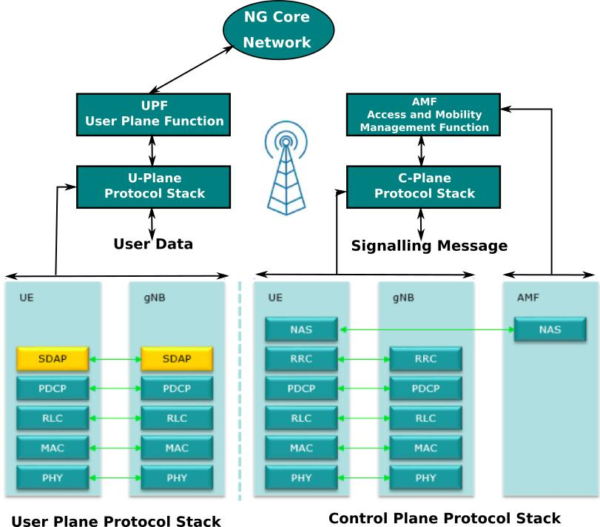

8.5 Protocol Exchanges During Handoff
The protocol stack supports mobility through measurement reports and signalling messages.
The sequence is:
- RRC configures measurements.
- The mobile station measures neighbouring cells.
- The mobile station sends a measurement report.
- The serving network makes a handoff decision.
- Target-cell resources are prepared.
- The mobile station receives a handoff command.
- The mobile station connects to the target cell.
- The user-plane path is updated.

8.6 Impact of Protocol Stack on Network Performance
Protocol component | Performance impact
PHY | Signal quality and data rate
MAC | Scheduling and resource utilisation
RLC | Reliability and retransmission delay
PDCP | Security and packet processing
RRC | Mobility and signalling overhead
IP | Packet routing and forwarding
TCP/UDP | Transport reliability and delay
Application | User experience

8.7 Limitations and Interoperability
Protocol operation may be affected by:
- Delayed signalling.
- Radio retransmissions.
- Network congestion.
- Backhaul limitations.
- Different vendor implementations.
- Compatibility between network generations.
The university network should use standards-compliant equipment and perform interoperability testing.
Result: The protocol stack enables communication between mobile stations, base stations and the core network. Efficient protocol operation improves throughput, reliability, mobility and service continuity.

9. TASK 8 – MODEL AND TEST THE PROPOSED STRATEGIES

9.1 Introduction
Network modelling and testing are required to evaluate whether the proposed cellular strategies can support the increasing number of users.
A model represents the network using a set of assumptions, formulas and test conditions.
The three strategies are tested under comparable user loads.
The purpose is to identify capacity limitations, resource utilisation and mobility-related overhead.

9.2 Objectives of Testing
- Evaluate the performance of three cellular strategies.
- Compare capacity at different user loads.
- Examine the impact of increasing traffic.
- Evaluate normal and high mobility conditions.
- Identify possible interference and congestion.
- Determine the most suitable strategy for 50,000 users.

9.3 Testing Environment
The following assumptions are used.
Parameter | Value
Coverage area | 10 km²
Initial users | 1,000
Second stage | 10,000
Third stage | 25,000
Peak users | 50,000
Data concurrency | 15%
Average data rate | 0.5 Mbps
Voice concurrency | 5%
Macro capacity | 0.72 Gbps
Small-cell capacity | 6 Gbps
Hybrid capacity | 4.32 Gbps

9.4 Test Cases
Test Case 1 – Low User Load
Number of users: 1,000.
Purpose:
To check the basic network operation under low traffic demand.
Expected result:
All three strategies should provide sufficient aggregate capacity.
Test Case 2 – Medium User Load
Number of users: 10,000.
Purpose:
To analyse performance when traffic demand increases.
Expected result:
The macrocell network begins to experience capacity limitations under the selected assumptions.
Test Case 3 – High User Load
Number of users: 25,000.
Purpose:
To evaluate the effect of increased user density.
Expected result:
The macrocell network experiences significant congestion, while small-cell and hybrid strategies have greater aggregate capacity.
Test Case 4 – Peak User Load
Number of users: 50,000.
Purpose:
To determine whether each strategy supports peak-hour demand.
Expected result:
The hybrid and small-cell strategies provide greater nominal capacity than the macrocell strategy.
Test Case 5 – High Mobility
Number of users: 50,000.
Condition:
Users frequently move between cells.
Purpose:
To examine handoff signalling and mobility overhead.
Expected result:
Small-cell networks experience more handoff activity because of their smaller coverage areas.

9.5 Testing Procedure
- Define the campus coverage area.
- Select the three network strategies.
- Assign the required number of base stations.
- Set the available bandwidth.
- Define frequency reuse patterns.
- Set the number of mobile users.
- Calculate data and voice traffic demand.
- Calculate available network capacity.
- Introduce normal mobility conditions.
- Introduce high-mobility conditions.
- Calculate resource utilisation.
- Compare the performance of all three strategies.
- Record the results in tables and graphs.

9.6 Pseudocode for the Analytical Model
START

Define user_levels = [1000, 10000, 25000, 50000]

Define:
Macro_capacity = 0.72 Gbps
Small_capacity = 6.00 Gbps
Hybrid_capacity = 4.32 Gbps

FOR each user_level:

Data_users = user_level * 0.15

Data_demand = Data_users * 0.5

Voice_demand = user_level * 0.05 * 0.024

Total_demand = Data_demand + Voice_demand

FOR each strategy:

Utilisation = Total_demand / Capacity

Calculate served capacity

Calculate capacity shortfall

Display results

END FOR

Calculate handoff requirements

Display comparison

STOP

9.7 Expected Testing Outcome
The macrocell strategy is expected to perform well under low traffic conditions.
The small-cell strategy is expected to provide high capacity but requires more mobility coordination.
The hybrid strategy is expected to provide balanced coverage and capacity.
Result: The analytical testing procedure provides a common basis for comparing the three cellular network strategies under increasing user loads.

10. TASK 9 – RECORD EXPERIMENTAL PERFORMANCE

10.1 Introduction
Performance recording is necessary to understand how the proposed strategies behave under different operating conditions.
The main parameters recorded are:
- Network capacity.
- Traffic demand.
- Resource utilisation.
- Handoff requirements.
- Capacity shortfall.
Important: The following results are calculated model outputs using the assumptions stated earlier. They are not actual measurements from a deployed university network.

10.2 Capacity and Traffic Results
Users | Demand | Macro capacity | Small-cell capacity | Hybrid capacity
1,000 | 0.0762 Gbps | 0.72 Gbps | 6 Gbps | 4.32 Gbps
10,000 | 0.762 Gbps | 0.72 Gbps | 6 Gbps | 4.32 Gbps
25,000 | 1.905 Gbps | 0.72 Gbps | 6 Gbps | 4.32 Gbps
50,000 | 3.810 Gbps | 0.72 Gbps | 6 Gbps | 4.32 Gbps

10.3 Resource Utilisation Calculation
Formula:
\[ U_r=\frac{\text{Traffic Demand}}{\text{Network Capacity}}\times100 \]

Macrocell at 50,000 users
U_r = 3.82/0.72 * 100
529.17 %
This means the estimated demand is much higher than the nominal capacity.

Small-cell at 50,000 users
U_r = 3.81/6 * 100
63.5 %

Hybrid at 50,000 users
U_r = 3.81/4.3 * 100
88.19 %

10.4 Complete Resource Utilisation Table
Users | Macrocell | Small-cell | Hybrid
1,000 | 10.58% | 1.27% | 1.76%
10,000 | 105.83% | 12.70% | 17.64%
25,000 | 264.58% | 31.75% | 44.10%
50,000 | 529.17% | 63.50% | 88.19%
Values above 100% indicate that the modelled demand exceeds nominal capacity; they are not achievable physical utilisation levels.

10.5 Handoff Performance Results
Assuming 2% of active users perform handoff per minute under normal mobility:
Users | Handoffs per minute
1,000 | 20
10,000 | 200
25,000 | 500
50,000 | 1,000
Under high mobility, assuming 5% per minute:
Users | Handoffs per minute
1,000 | 50
10,000 | 500
25,000 | 1,250
50,000 | 2,500

10.6 Performance Interpretation
The results show that the macrocell strategy exceeds its nominal capacity as the user population grows.
The small-cell strategy maintains a higher capacity because it uses multiple small coverage areas.
The hybrid network provides sufficient aggregate nominal capacity for the assumed 50,000-user demand, although its remaining capacity reserve is limited.

10.7 Graphical Representation
The following graphs should be included in the final Word assignment:
- Number of users versus traffic demand.
- Strategy versus network capacity.
- Number of users versus resource utilisation.
- Normal mobility versus high-mobility handoff requirements.
These graphs help identify the differences between the proposed strategies.
Result: The recorded model outputs indicate that the hybrid strategy provides a practical balance between capacity and infrastructure requirements.

11. TASK 10 – COMPARE EXPECTED AND OBSERVED BEHAVIOUR

11.1 Introduction
Expected behaviour refers to the performance predicted during the network design stage.
Observed behaviour refers to the performance obtained after modelling, simulation or testing.
Comparing these results helps determine whether the proposed network strategies meet their objectives.
In this assignment, the comparison is based on the analytical model results from Task 9.

11.2 Expected and Modelled Performance
Strategy | Expected behaviour | Modelled behaviour
Macrocell | Good performance at low user loads | Capacity becomes insufficient at 10,000 users
Small-cell | High capacity through frequency reuse | Supports the estimated aggregate demand at 50,000 users
Hybrid | Balanced capacity and coverage | Supports the estimated demand with limited reserve

11.3 Strategy 1 – Macrocell
Expected behaviour:
The macrocell network is expected to provide good coverage and stable communication when the number of users is low.
As the number of users increases, the available bandwidth is shared among more users.
Modelled behaviour:
At 1,000 users, the demand is only 76.2 Mbps, which is within the estimated capacity of 720 Mbps.
At 50,000 users, demand increases to 3.81 Gbps.
However, the available capacity remains 0.72 Gbps.
Therefore, the network cannot satisfy the estimated demand.
Reason for difference:
The macrocell network has limited capacity and cannot efficiently support a large number of users without additional infrastructure or spectrum.

11.4 Strategy 2 – Small-Cell
Expected behaviour:
Small-cell networks are expected to provide high capacity because they use multiple low-power base stations.
Modelled behaviour:
The estimated capacity is 6 Gbps, which is higher than the 3.81 Gbps demand at 50,000 users.
Reason for performance:
- Shorter transmission distances.
- Spatial frequency reuse.
- Increased number of radio access points.
- Better indoor coverage.
However, the actual performance may decrease if backhaul links become congested or interference increases.

11.5 Strategy 3 – Hybrid
Expected behaviour:
The hybrid network is expected to combine the coverage benefits of macrocells with the capacity benefits of small cells.
Modelled behaviour:
The estimated capacity is 4.32 Gbps.
At 50,000 users, the estimated demand is 3.81 Gbps.
Therefore, the network can support the assumed aggregate traffic.
Reason for performance:
- Macro cells provide wide-area coverage.
- Small cells provide additional capacity.
- Traffic can be distributed between network layers.
- Mobility can be managed using the macro coverage layer.

11.6 Reasons for Differences Between Expected and Actual Performance
In a real deployment, performance may differ from the analytical model because of:
1. Interference
Neighbouring base stations may interfere with one another and reduce the achievable data rate.
2. Signalling Overhead
Authentication, connection establishment and handoff require additional signalling.
3. Access Contention
Multiple mobile devices may request network access simultaneously.
4. Resource Limitations
Available bandwidth, radio resources and backhaul capacity are limited.
5. Mobility
Frequent movement increases handoff activity and signalling requirements.
6. Uneven Traffic Distribution
Some buildings may contain significantly more users than others, creating local congestion.

11.7 Overall Comparison
The modelled results support the original expectation that macrocell-only architecture is unsuitable for the peak demand.
Small-cell architecture provides high nominal capacity but requires more infrastructure.
Hybrid architecture offers a better balance between capacity, coverage and mobility.
Result: The analytical model supports the hybrid network as the preferred design, but actual deployment performance must be verified through field measurements and realistic simulation.

12. TASK 11 – RECOMMEND AND DEFEND THE FINAL DESIGN

12.1 Introduction
After analysing the three proposed cellular network strategies, a final design must be selected for the university.
The selection must consider:
- Network capacity.
- Coverage.
- Frequency reuse.
- Interference.
- Handoff.
- Mobility.
- Infrastructure requirements.
- Scalability.
- Cost and maintenance.

12.2 Final Recommended Strategy
Recommended design
Hybrid Macrocell and Small-Cell Cellular Network
The hybrid cellular network is recommended because it combines the advantages of macrocell and small-cell architectures.
The macrocell layer provides continuous coverage across the university and surrounding residential area.
Small cells provide additional capacity in crowded locations such as classrooms, libraries, hostels and cafeterias.

12.3 Reasons for Selecting the Hybrid Network
1. Better Coverage
Macro base stations provide wide-area coverage throughout the university.
2. Higher Capacity
Small cells increase the available capacity in high-density locations.
3. Better Mobility Support
The macro layer provides a stable coverage layer while users move between small-cell areas.
4. Improved Resource Utilisation
Users can be distributed between the macro and small-cell layers according to network conditions.
5. Scalability
Additional small cells can be installed when traffic demand increases.
6. Reduced Congestion
Crowded locations can receive additional radio resources through small-cell deployment.

12.4 Recommended Network Components
Component | Recommended function
Mobile Stations | Student and staff devices
Macro Base Stations | Wide-area coverage
Small-Cell Base Stations | Local capacity enhancement
RAN Controller | Radio resource coordination
Core Network | Authentication and session management
Backhaul Network | Connects base stations to the core
Internet Gateway | Provides external connectivity
Network Management System | Monitoring and fault management

12.5 Recommended Implementation Plan
Phase 1 – Network Survey
Study the university layout and identify areas with high user density.
Phase 2 – Macrocell Deployment
Install macro base stations to provide basic outdoor coverage.
Phase 3 – Small-Cell Deployment
Install small cells in crowded buildings and high-demand areas.
Phase 4 – Network Configuration
Configure frequency resources, transmission power and mobility parameters.
Phase 5 – Performance Testing
Test throughput, delay, handoff and interference.
Phase 6 – Network Optimisation
Improve resource allocation based on measured performance.
Phase 7 – Future Expansion
Install additional small cells or upgrade capacity when demand increases.

12.6 Risks and Solutions
Risk | Proposed solution
High interference | Frequency and power coordination
Handoff failures | Optimise mobility parameters
Backhaul congestion | Increase backhaul capacity
Base station failure | Provide macro coverage fallback
High traffic demand | Add capacity at hotspots
Poor indoor coverage | Install indoor small cells

12.7 Final Justification
The estimated traffic demand for 50,000 users is 3.81 Gbps.
The three strategies provide the following nominal capacities:
Strategy | Capacity | Decision
Macrocell | 0.72 Gbps | Insufficient
Small-cell | 6.00 Gbps | High capacity, greater infrastructure complexity
Hybrid | 4.32 Gbps | Recommended balance
The hybrid design provides sufficient estimated aggregate capacity under the assumptions used in this report.
It also offers better coverage and mobility support than a small-cell-only approach.
Result: The hybrid macrocell and small-cell network is recommended as the most suitable cellular communication strategy for the university.

13. TASK 12 – RE-EVALUATE AND ADAPT THE DESIGN

13.1 Introduction
The university has introduced a new requirement to support 50,000 active mobile users during peak hours.
Users frequently move between cells, while the available network infrastructure and frequency resources are limited.
This requirement creates additional challenges for the original network design.
The original solution must be evaluated and modified if necessary.
The three possible decisions are:
- Retain the existing design.
- Modify the existing design.
- Completely redesign the network.
The proposed decision is to modify the hybrid network.

13.2 A. Impact Analysis

13.2.1 Changes in Requirements
- The new requirements include:
- Increase in active users to 50,000.
- Higher data traffic demand.
- Frequent movement between cells.
- Limited frequency spectrum.
- Increased interference.
- Greater handoff requirements.
- Increased demand for base station resources.
- Requirement for continuous connectivity.

13.2.2 Impact of Increasing Users
As the number of users increases, the amount of network traffic also increases.
The estimated traffic demand is:
Users | Estimated demand
1,000 | 76.2 Mbps
10,000 | 762 Mbps
25,000 | 1.905 Gbps
50,000 | 3.81 Gbps
This shows that the network must support considerably higher traffic than the initial configuration.

13.2.3 Impact of User Mobility
Frequent movement between cells increases handoff requirements.
For 50,000 users:
Normal handoff estimate:
50000*0.02 = 1000
High-mobility estimate:
50000 * 0.05 = 2500
Therefore, the network may need to process approximately 2,500 handoffs per minute under the assumed high-mobility condition.

13.2.4 Impact of Limited Frequency Resources
Frequency spectrum is a limited resource.
When more users connect to the network, the available frequency resources must be shared efficiently.
Poor frequency allocation can cause:
- Co-channel interference.
- Adjacent-channel interference.
- Reduced throughput.
- Increased retransmissions.
- Network congestion.
Frequency reuse and interference coordination are therefore essential.

13.2.5 Overall Impact Analysis
Changed requirement | Impact on network
50,000 users | Higher capacity requirement
Increased traffic | More bandwidth and radio resources
Frequent movement | More handoff signalling
Limited spectrum | Need for efficient frequency reuse
High user density | Increased interference and congestion
Limited infrastructure | Need for targeted deployment
Conclusion: The original network design must be modified to support the changed requirements.

13.3 B. Evaluation of the Original Design
The original hybrid strategy was selected because it provides a combination of wide-area coverage and high local capacity.
However, the network must now be evaluated against the new 50,000-user requirement.

13.3.1 Capacity Evaluation
Original macrocell capacity:
C_m=0.72 Gbps
Original small-cell capacity:
C_s=6 Gbps
Original hybrid capacity:
C_h=4.32 Gbps
Required demand:
D=3.81 Gbps
The macrocell design cannot meet the estimated demand.
The small-cell design has sufficient nominal capacity, but requires many small cells and backhaul connections.
The hybrid design provides sufficient aggregate capacity, but the remaining reserve is limited.

13.3.2 Evaluation of Cell Layout
The original hybrid design includes:
- 12 macro sites.
- 36 macro sectors.
- 60 small cells.
The macro sites provide coverage across the university.
The small cells provide additional capacity in crowded locations.
However, some buildings may experience higher traffic than others.
Therefore, the number and location of small cells must be determined using actual user-density information.

13.3.3 Evaluation of Frequency Allocation
The original design uses:
- Reuse-3 planning for macro cells.
- Reuse-1 planning for suitable small cells.
This can improve spectrum utilisation.
However, neighbouring small cells must coordinate their transmission resources to prevent excessive interference.

13.3.4 Evaluation of Handoff
The hybrid network supports movement between macro and small-cell layers.
However, high user mobility may increase signalling and handoff requests.
The network must improve:
- Neighbour-cell configuration.
- Handoff thresholds.
- Target-cell admission control.
- Radio resource reservation.
- Backhaul reliability.

13.3.5 Overall Evaluation
Criteria | Original hybrid design | Evaluation
Capacity | 4.32 Gbps | Sufficient for assumed aggregate demand, with limited reserve
Coverage | Macro layer | Suitable foundation
Frequency planning | Reuse-3 and reuse-1 | Requires coordination
Handoff | Inter-layer mobility | Requires optimisation
Infrastructure | 12 macro sites and 60 small cells | Requires hotspot validation
Scalability | Small-cell expansion | Suitable for phased growth

13.4 C. Adaptation or Redesign

13.4.1 Selected Decision: MODIFY
The original hybrid network will be modified rather than completely redesigned.
The existing macrocell infrastructure will be retained.
Small cells will be added or relocated according to actual traffic demand.

13.4.2 Proposed Modifications
1. Increase Small-Cell Capacity
Additional small cells will be installed in buildings where the existing network experiences congestion.
2. Improve Frequency Planning
Frequency reuse and interference coordination will be optimised.
3. Improve Mobility Management
Handoff thresholds and neighbour-cell configurations will be adjusted.
4. Improve Backhaul
High-capacity backhaul connections will be provided for crowded locations.
5. Implement Load Balancing
Users will be distributed between macro and small-cell layers according to radio quality and available resources.
6. Monitor Network Performance
The network will continuously monitor traffic demand, resource utilisation and handoff success.

13.4.3 Revised Network Architecture
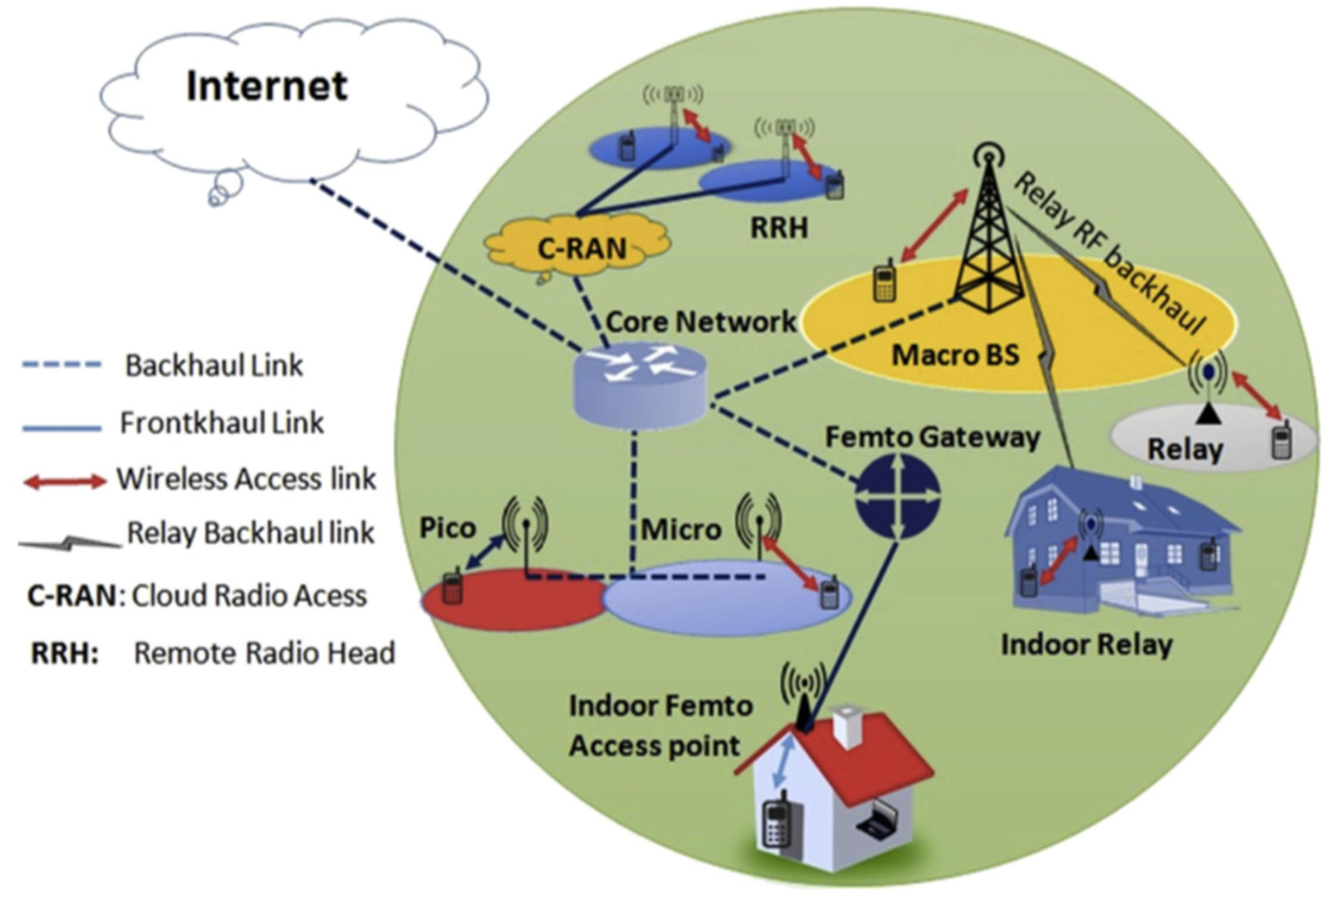

The revised architecture contains:
- Mobile stations.
- Macro base stations.
- Small-cell base stations.
- Coordinated Radio Access Network.
- Core network.
- Backhaul infrastructure.
- Internet gateway.
- Network management system.

13.4.4 Original Design Versus Modified Design
Parameter | Original design | Modified design
Macro infrastructure | 12 macro sites | Retained
Small cells | 60 | 60 plus additional nodes where required
Frequency reuse | Reuse-3 and reuse-1 | Optimised coordinated reuse
Handoff | Basic inter-layer handoff | Optimised mobility and admission control
Resource allocation | Initial planning | Load-aware scheduling
Backhaul | Basic connectivity | Improved capacity and redundancy
Monitoring | Basic monitoring | Continuous performance monitoring

13.4.5 Expected Effect of Modifications
Modification | Expected benefit
Additional small cells | Increased local capacity
Frequency coordination | Reduced interference
Better handoff configuration | Improved service continuity
Backhaul improvement | Reduced transport congestion
Load balancing | Better resource utilisation
Network monitoring | Faster identification of problems

13.5 D. Evidence-Based Defence
The final design decision must be supported by numerical calculations and performance analysis.

13.5.1 Capacity Evidence
Estimated demand:
D=3.81 Gbps
Hybrid capacity:
C=4.32 Gbps
Capacity margin:
M=C-D
M=4.32-3.81
M=0.51 Gbps
Therefore, the hybrid network provides an estimated capacity margin of 510 Mbps.

13.5.2 Resource Utilisation
Ur = 3.81/4.32 * 100
Ur = 88.19 %
This indicates that approximately 88.19% of the estimated nominal capacity is required at peak load.
The remaining reserve is approximately 11.81%.

13.5.3 Frequency Reuse Evidence
The hybrid network uses macrocell frequency planning and small-cell spatial reuse.
This allows the network to use limited frequency resources more efficiently.

13.5.4 Mobility Evidence
At 50,000 users, the estimated handoff requirement under high mobility is 2,500 handoffs per minute.
Therefore, mobility coordination and target-cell resource availability must be improved.

13.5.5 Infrastructure Evidence
The hybrid network uses the existing macro infrastructure and adds small cells only where additional capacity is required.
This avoids the need to install a dense small-cell network throughout the entire university.

13.5.6 Final Defence
The hybrid network is selected because:
- It provides wide-area coverage.
- It supports high-density locations.
- It offers sufficient estimated aggregate capacity for the assumed peak demand.
- It improves mobility support through the macro layer.
- It uses available spectrum more efficiently through coordinated reuse.
- It supports phased infrastructure expansion.
- It provides a practical balance between performance and deployment complexity.
However, the 11.81% capacity reserve is relatively limited. Therefore, actual traffic measurements must be used to determine whether further expansion is required.
Final Result: The original hybrid design is modified to support 50,000 active users. The modified design provides a scalable approach for improving cellular network capacity, coverage and mobility.

14. OVERALL CONCLUSION
This assignment analysed three different cellular network strategies for providing reliable mobile communication services in a university environment.
The three proposed strategies were traditional macrocell-based networking, dense small-cell-based networking and hybrid macrocell and small-cell networking.
The macrocell strategy provides wide geographical coverage using fewer base stations. However, its capacity becomes insufficient when the number of active users increases significantly.
The small-cell strategy provides higher capacity through spatial frequency reuse and improves indoor connectivity. However, it requires more base stations, reliable backhaul and efficient handoff management.
The hybrid strategy combines the advantages of both approaches. Macro cells provide wide-area coverage, while small cells provide additional capacity in crowded locations.
Based on the illustrative calculations, 50,000 active users generate an estimated traffic demand of 3.81 Gbps. The macrocell strategy provides 0.72 Gbps, the small-cell strategy provides 6 Gbps and the hybrid strategy provides 4.32 Gbps of nominal estimated capacity.
Therefore, the hybrid strategy is selected as the most balanced design for the university.
The original hybrid architecture is modified by improving small-cell deployment, frequency coordination, handoff management, backhaul connectivity and network monitoring.
The study concludes that an efficient cellular network must provide sufficient capacity, reliable coverage, effective interference management and continuous connectivity during user movement.
A real deployment must finally be validated using actual campus measurements, operator spectrum information and detailed network simulation.

MARK DISTRIBUTION
Task | Marks
Task 1 – Cellular Network Strategy | 5
Task 2 – Basic Network Operation | 2
Task 3 – Capacity and Resource Analysis | 6
Task 4 – Best/Average/Worst-Case Analysis | 4
Task 5 – Comparative Performance Analysis | 3
Task 6 – Mobility and Handoff Procedure | 3
Task 7 – Protocol Stack Evaluation | 4
Task 8 – Modelling and Testing | 4
Task 9 – Experimental Performance | 3
Task 10 – Expected vs Observed Behaviour | 4
Task 11 – Final Design Recommendation | 4
Subtotal | 42
Task 12 – Day-4 Design Challenge | 8
TOTAL | 50

